*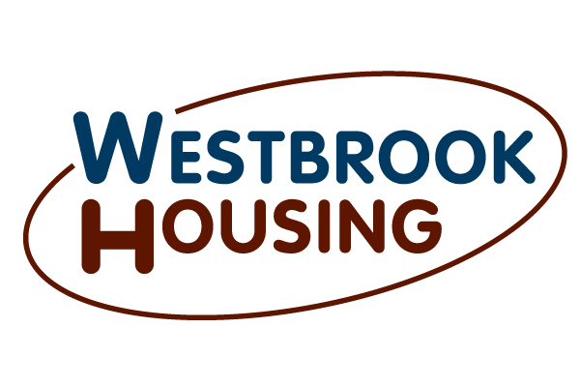

Jurisdiction-

Westbrook, Windham, Gorham, Portland, Falmouth, Cumberland, Old Orchard Beach, Scarborough, Cape Elizabeth, Yarmouth, North Yarmouth, Gray, New Gloucester, Standish, Buxton.

Payment Standards for Westbrook Housing effective May 1, 2017

0 Bedroom - $820

1 Bedroom - $926

2 Bedroom - $1171

3 Bedroom - $1580

4 Bedroom - $1716

The above figures are for all utilities included.

Refer to the chart below for the amount allowed for tenant paid utilities. Deduct the cost for tenant paid utilities from the Payment Standard to determine a contract rent that would ensure a tenant pays 30% of their income. Single family homes and high-rise units use a different chart.

|  |  |  |  |  |  |  |  |
| --- | --- | --- | --- | --- | --- | --- | --- |
| Utility or Service | | Monthly Dollar Allowance | | | | | |
| 0 BR | 1 BR | 2 BR | 3 BR | 4 BR | 5 BR |
| Heating | Natural Gas | 47 | 57 | 66 | 75 | 85 | 98 |
|  | Bottle Gas | 74 | 104 | 110 | 138 | 176 | 196 |
|  | Oil | 50 | 69 | 90 | 111 | 137 | 156 |
|  | Electric | 57 | 75 | 86 | 103 | 126 | 161 |
|  | Kerosene | 39 | 49 | 59 | 74 | 90 | 101 |
| Cooking | Natural Gas | 2 | 3 | 4 | 5 | 6 | 7 |
|  | Bottle Gas | 14 | 16 | 20 | 25 | 32 | 36 |
|  | Electric | 7 | 9 | 12 | 14 | 18 | 21 |
| Other Electric |  | 27 | 31 | 38 | 45 | 46 | 59 |
| Air Conditioning |  | N/A | N/A | N/A | N/A | N/A | N/A |
| Water Heating | Natural Gas | 8 | 12 | 15 | 18 | 23 | 27 |
|  | Bottle Gas | 11 | 14 | 18 | 23 | 27 | 32 |
|  | Oil | 10 | 11 | 15 | 19 | 23 | 27 |
|  | Electric | 20 | 24 | 35 | 46 | 58 | 67 |
| Water |  | 11 | 18 | 22 | 33 | 37 | 48 |
| Sewer |  | 18 | 44 | 62 | 106 | 123 | 167 |
| Trash Removal |  | 8 | 8 | 9 | 13 | 19 | 23 |
| Range/Microwave |  | 7 | 7 | 7 | 7 | 7 | 7 |
| Refrigerator |  | 7 | 7 | 7 | 7 | 7 | 7 |
|  |  |  |  |  |  |  |  |

**Occupancy Standards**

Occupancy Standards determine the size of unit for which your family is eligible. You are not restricted to find a unit the same as the bedroom size of your subsidy. If you find a smaller unit, you must use the Payment Standard of the unit size. If you find a larger unit, you must use the Payment Standard of your family’s Occupancy Standard.

* Two adults will be allocated one bedroom; an adult is a person 18 or older, regardless of sex and relationship.
* Children of the opposite sex will be allocated a shared bedroom until one reaches the age of 7.
* Live-in aides will be allocated a separate bedroom.
* Single person families will be allocated one bedroom

**Remember to report all changes in writing within 10 days of the change**

The most common changes to report are if a household member moves out, if you would like to add a member to your household, if your income increases or if your income decreases. You must report these changes, in writing, by mail, email or in person at the front desk within 10 days of the change. Make sure the name of the head-of-household is on all documents provided. Failure to comply may result in program termination.

Written changes received after the 20th of the month may not be processed by the 1st of the next month. This is especially important to remember if you are reporting a decrease in income. Providing 6-weeks’ pay stubs or a letter from your income source may help shorten the amount of time needed to process your rent adjustment.

**What to do when you have a question**

You may contact your program officer by phone, mail or email. If you come into the office without an appointment, you will be asked to complete an Appointment Request form. We ask that you be respectful to the receptionist who greets you, they have specific instructions on how to direct you for the best possible service. They are not authorized to answer any program questions. They would be happy to photocopy any documentation you would like to provide to your program officer.

Once you have contacted your program officer, your request will be processed accordingly. This means you may receive a phone call, letter or email. Depending on the nature of your situation, you may get a response on the same day or it may take several weeks to process. We will contact you if we have any questions. The more information you provide, the faster we are likely to process your request. For example, if you are asking a general question, you may get an immediate phone call. If you are reporting a change in your income, providing documentation from the income source would make for a faster response than if you simply write that your income has changed.

**Annual Appointments**

It is very important for you to make every effort to attend your annual reexamination and inspection appointments. Being on time and prepared is key to your successful program participation. If you are late or unprepared, your appointment will be rescheduled. If you are working, attending school or have a medical appointment at the time of your reexamination or inspection, please call several days in advance to reschedule. Failure to comply may result in program termination.