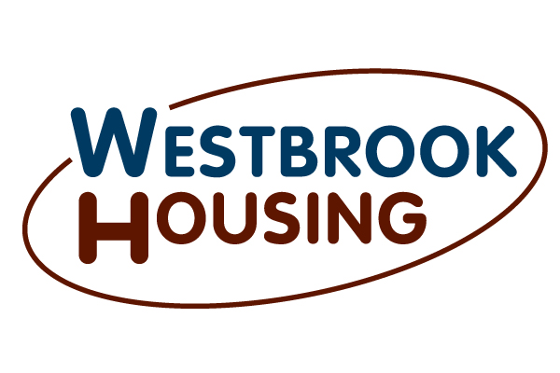

HOUSING INTAKE SPECIALIST
COMPLIANCE ASSISTANT

Property Management Division

The position of Housing Intake Specialist and Compliance Assistant is directly responsible for performing daily tasks related to the property management division. This position will be under the supervision of the Director of Property Management. This position will be responsible for the intake of new housing applications and entering new applicant information into our software system. The Intake Specialist and Compliance Assistant is also responsible for coordinating the advertising and marketing of Westbrook Housing owned developments. Responsibilities would also include providing assistance to Westbrook Housings Compliance Specialist in obtaining and verifying information for housing program eligibility.

ESSENTIAL FUNCTIONS:

- Maintain and provide information on WH communities, services and policies to interested persons.

- Application entry and maintaining and updating WH’s Property Management waiting lists in accordance with regulation or policy; to include annually purging the lists.

- Ensuring that housing applications are correctly filled out by potential applicants before entry onto Westbrook Housing property waitlists. Applications that have not been completed correctly will promptly need to be returned to the applicant for further clarification; followed-up with via telephone call and/or fax (whatever is necessary to secure the correct information).

- Process resident move outs to include all of the related paperwork for the residents moving out of Westbrook Housing’s owned and/or managed rental properties.

- Run background checks on potential applicants.

- Assist in keeping all forms, policies, letters and correspondence related to this position updated according to the latest regulations and on current letterhead.

- Schedule appointments, initial paper set-up, third party verifications, interviewing participants, completing final paperwork for housing eligibility.

- Work with property management to ensure adherence to accurate verification procedures and filing.

- Coordinate all marketing related activities for Westbrook Housing properties.

- Share in the backing up of the front reception area as needed by filling in as the receptionist to the general public, answering phones and greeting residents and walk-ins. Typically, this is just going to be required for break periods, but could be for long periods if needed to cover an unanticipated absence.

- Responsible for collaborating with a variety of staff including; property manager, maintenance, development team, supportive service team and others to complete tasks.

- Other duties as assigned.

REQUIREMENTS OF WORK:

- Ability to work independently with minimal supervision.

- Ability to problem-solve issues of conflict with potential applicants.

3. Ability to organize materials and complete special projects as assigned.

- Ability to deal in a positive and friendly manner with a variety of people from diverse backgrounds to include: the elderly and disabled, low-income families, city, state and HUD officials, and also social services communities.

- Ability to use company related software as needed.

JOB QUALIFICATIONS:
1. Graduation from a standard high school or a GED.

2. Two or three years of related data entry experience preferred.

The above statements are intended to describe the general nature and level of work being performed by people assigned to do this job. The above is not intended to be an exhaustive list of all responsibilities and duties required.
External and internal applicants, as well as position incumbents who become disabled as defined under the Americans With Disabilities Act, must be able to perform the essential job functions (as listed) either unaided or with the assistance of a reasonable accommodation to be determined by management on a case by case basis.

REPORTS TO:
Director of Property Management

DIRECT REPORT:
None

CLASSIFICATION:
Status - Non Exempt

____________________________________ _____________________________
(Employee’ Signature) (Date) (Human Resources) (Date)

(Rev 03/18)

